**Congratulations!**

**Saying numbers in the correct order…**

Make some number cards.

Shuffle the cards. Can you put them in the right order?

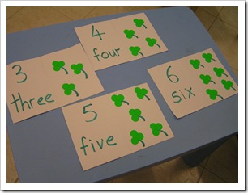

Take one card away. Which number is missing?

**Counting …**

Count things you cannot touch such as jumps, claps, steps you take. 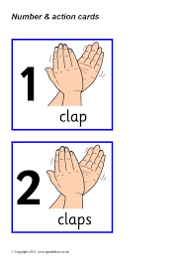

Count objects such as coins, pasta, shapes, buttons etc. Remember to move each object as you count them.

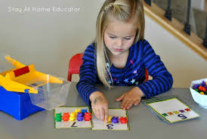

**You are starting on Europe.**

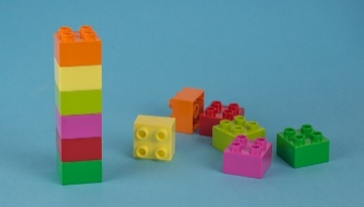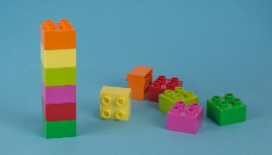

a

**1 2 3 4 5 6 7 8 9 10**

**Know the numbers…**

Dice game - write the numbers 1 to 6 on a sheet of paper. Throw a dice. Can you guess how many dots there are? Check by counting. Cover the number on the paper with a counter. 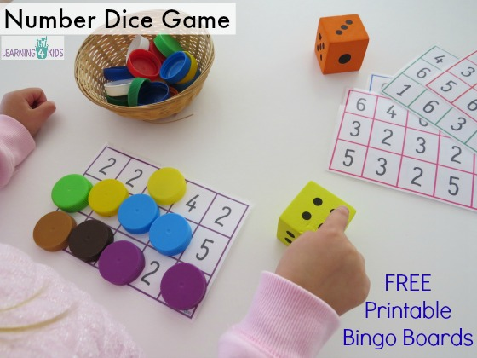

**‘One more, one less’ Game…**

You will need a dice, a coin and some Lego bricks.

Take turns to roll the dice. Build a lego tower with that number of bricks. Then toss the coin. Heads means take one brick off. Tails means add one on.

If you can say how many bricks there will be after this, you keep them. The first to collect 20 bricks or more wins.

|  |  |
| --- | --- |
|  | Say the numbers 0 – 10 in the correct order. |
| Know the numbers 1-5 |
| Know the numbers 6-10 |
| Know the numbers 11-20 |
| Say the number that is one more than (up to 20) |
| Say the number that is one less than (up to 20) |
|
|
|
|
|