**Congratulations on achieving Asia.**

Did you know that multiplying by 2 is the same as doubling?

When we multiply by 2 we are adding that number to itself.

2 X 2 is the same as two lots of 2.

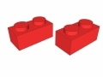

Try using lego pieces to help with learning 2 x tables!

Use fingers to support counting how many 2s.

Number Bonds

Make sure you know your number bonds to 10 really well!

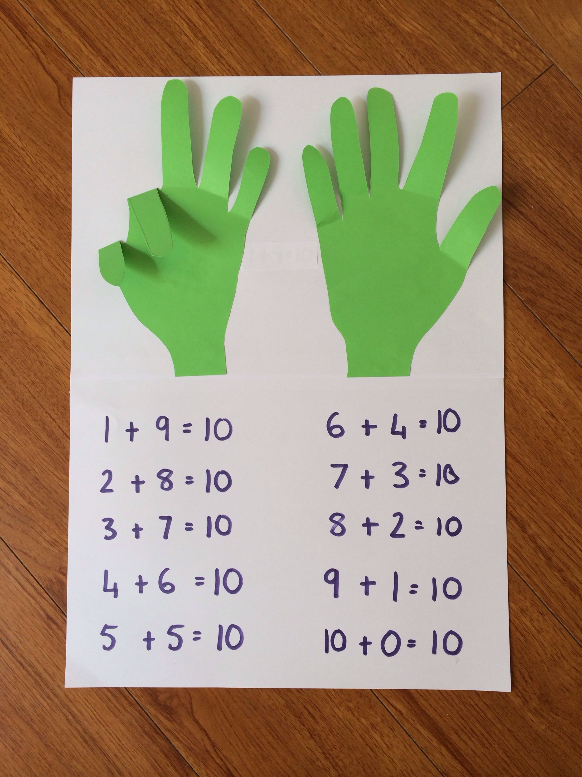

If you know 1 + 9 = 10 then you also know 10 + 90 = 100

You can also work out your number bonds to 20. Try making picture cards like these!

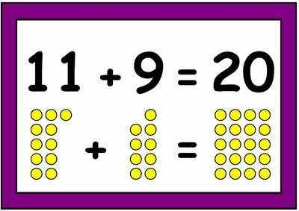

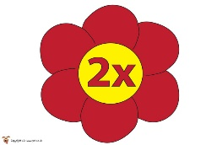 **You are moving on to Africa.**

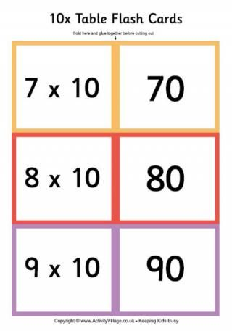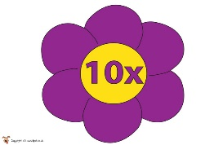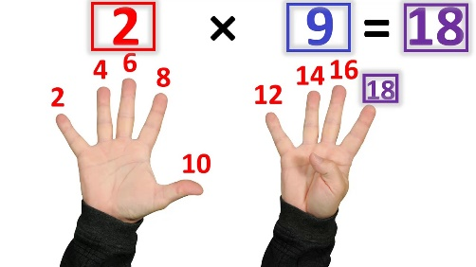

c

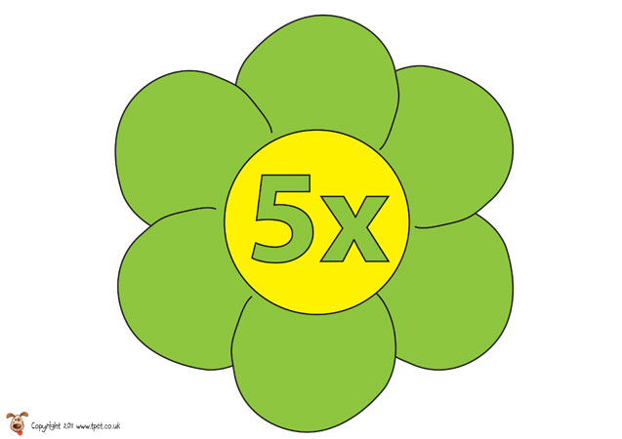 Make your own 5x times tables poster and recite the times tables before bedtime. Try writing a 5 x tables rap and learn it off by heart!

Make some 10 x times tables flash cards. Play a game of snap with your friends by matching the question to the answer.

Can you spot a pattern when counting forwards and backwards in 2’s, 5’s and 10’s?

http://process.arts.ac.uk/sites/default/files/u35/5s.jpg

**10 – 20 – 30 – 40 – 50 – 60 – 70 – 80 – 90 - 100**

**2 – 4 – 6 – 8 – 10 – 12 – 14 – 16 – 18 – 20 – 22 - 24**

|  |  |
| --- | --- |
|  | Know by heart all number bonds to 20 |
| Know by heart all bonds of multiples of 10 to 100. |
| Counting forwards and backwards in 2’s, 5’s and 10’s |
| Know by heart all multiplication facts up to 12 x 2 |
| Know by heart all multiplication facts up to 12 x 5 |
| Know by heart all multiplication facts up to 12 x 10 |
|