**Congratulations on achieving Africa.**

**You are moving on to Australasia.**

Mentally subtracting 9 and 11…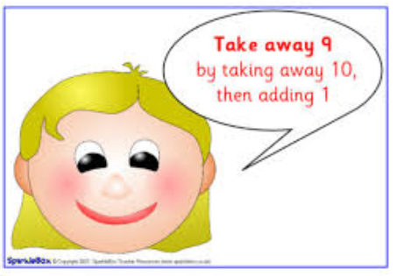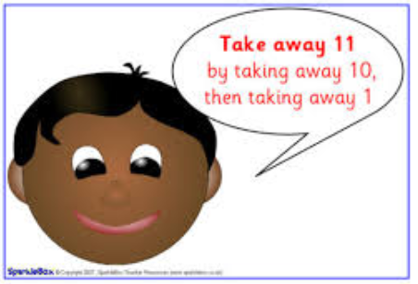

How could you mentally add 9 and 11? What would you say?



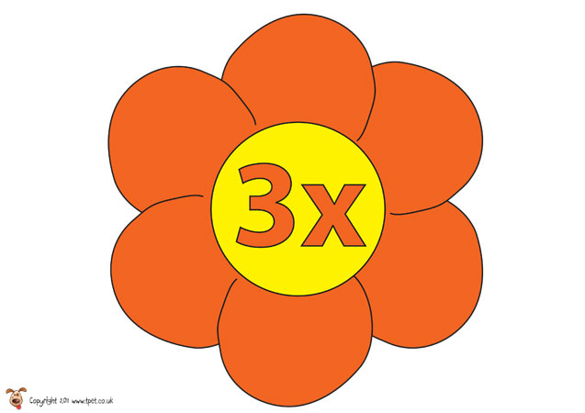

Know multiplication facts up to 12 x 3…

Try making your own 3 x tables flower!

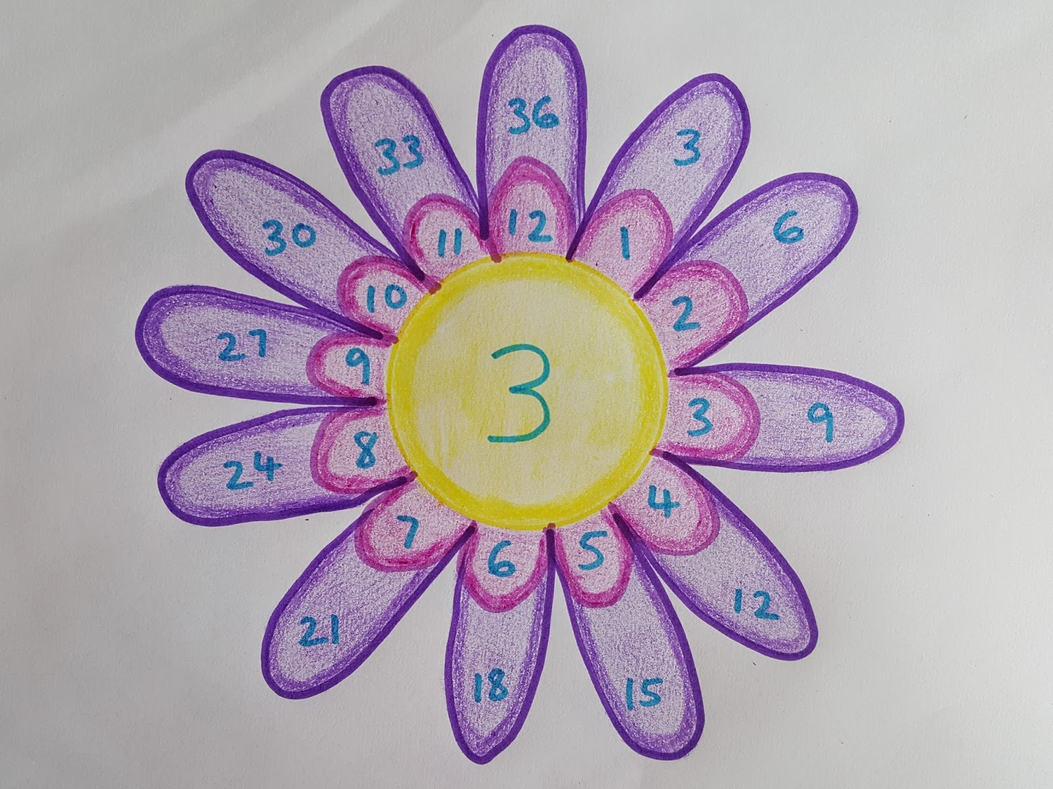

Use the petals to work out the answers

1 x 3 = ?

2 x 3 = ?

3 x 3 = ?

4 x 3 = ?

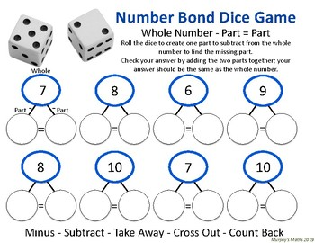

d

I can…

I know that…

Number bonds within 20…

* Play the Number bond dice game
* Draw some part/whole numbers
* Roll the dice
* Find the missing number!

Counting forwards in 3’s, 4’s and 8’s…

3 – 6 – 9 – 12 – 15 – 18 – 21 – 24 – 27 – 30 – 33 - 36

4 – 8 – 12 – 16 – 20 – 24 – 28 – 32 – 36 – 40 – 44 – 48

8 – 16 – 24 – 32 – 40 – 48 – 56 – 64 – 72 – 80 – 88 - 96

|  |  |
| --- | --- |
|  | Count forwards and backwards in 3’s |
| Know by heart all multiplication facts up to 12 x 3 |
| Count forwards in 4’s |
| Count forwards in 8’s |
| Know by heart all number bonds within 20 |
| Mentally add and subtract 9 and 11 from any given number |
|  |