**Congratulations on achieving North America.**

**You are moving on to South America.**

**Count forwards and backwards in…**

**sixes.**

6, 12, 18, …

**nines.**

9, 18, 27, 36, 42…

**elevens.**

11, 22, 33, 44, 55…

*This will help you when you come to learn your 6, 9 and 11 times tables.*

Can you see any patterns?

**Know by heart all multiplication facts up to 12 x 9.**

Learn the hand trick!

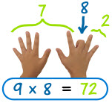

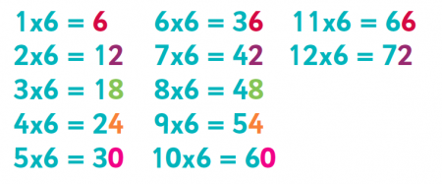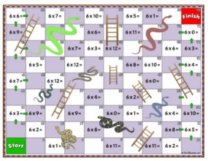

f

**Count forwards and backwards in tenths.**

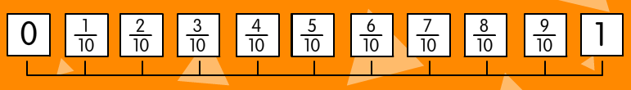

Make your own tenths number line. Ask a friend

to cover up some of your fractions. What’s missing?

Can you count beyond one in tenths?

|  |  |
| --- | --- |
|  | Count forwards and backwards in tenths. |
| Count forwards and backwards in sixes. |
| Count forwards and backwards in nines. |
| Count forwards and backwards in elevens. |
| Know by heart all multiplication facts up to 12 x 6. |
| Know by heart all multiplication facts up to 12 x 9. |
| Know by heart all multiplication facts up to 12 x 11. |

**Know by heart all multiplication facts up to 12 x 6.**

**TOP TIP:** The units digits

repeat themselves after 5x6 so try

learning your 6 times table in

two halves!

**Know by heart all multiplication facts up to 12 x 11.**

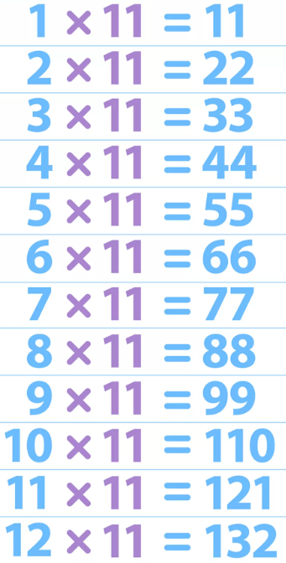

Why not make your own board game to practise your 6, 9 and 11 times tables?